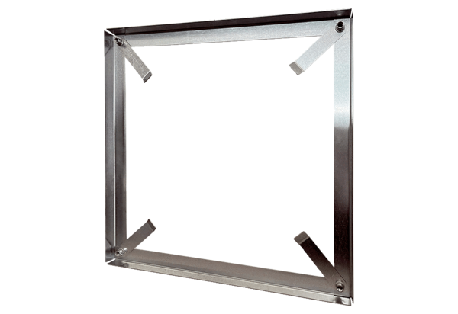Installation frame MRI 80-90Packing unit: 1 pieceRange: C
Article number: 0073.0066Manufacturer: MAICO

