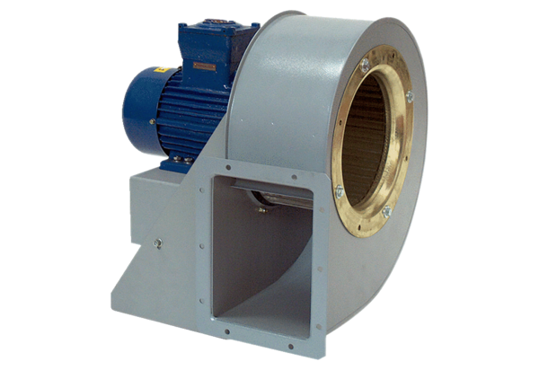Centrifugal blower GRM HD 25/4 ExPacking unit: 1 pieceRange: C
Article number: 0073.0401Manufacturer: MAICO

