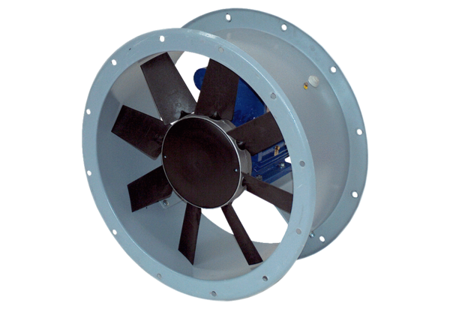Axial duct fan DAR 71/4 1,5Packing unit: 1 pieceRange: C
Article number: 0073.0129Manufacturer: MAICO

