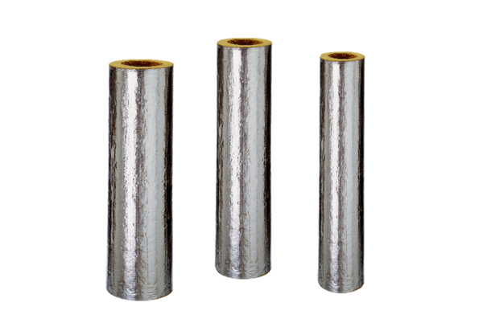Fire protection insulation BI 200Range: B
Article number: 0092.0398Manufacturer: MAICO

