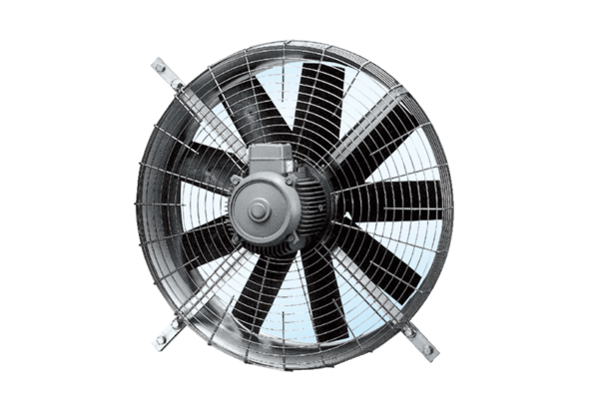Axial wall fan DZQ 71/8 APacking unit: 1 pieceRange: C
Article number: 0083.0641Manufacturer: MAICO

