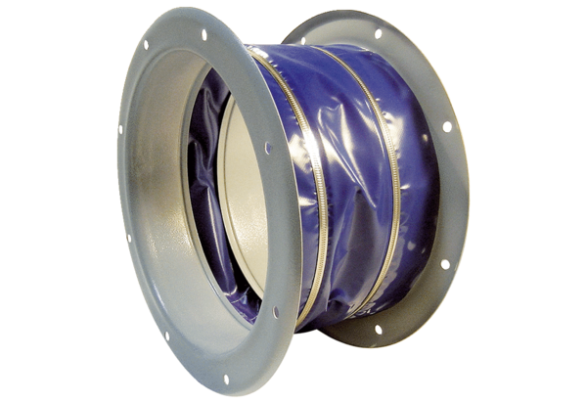Flexible coupling ELI 100Packing unit: 1 pieceRange: C
Article number: 0073.0222Manufacturer: MAICO

