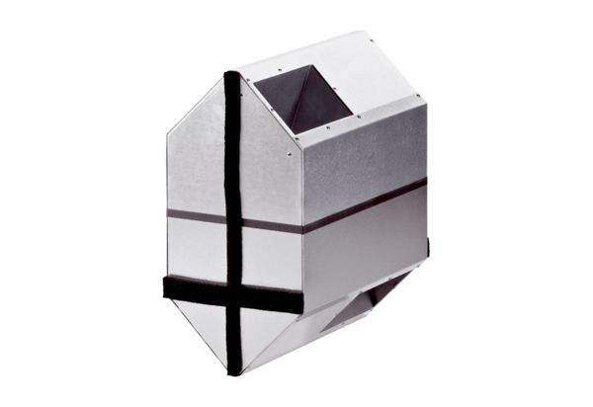Summer cassette WRSK 600Packing unit: 1 pieceRange: K
Article number: 0095.0153Manufacturer: MAICO

