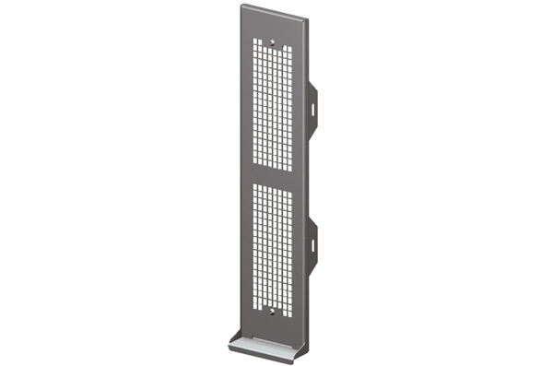Cover Duo AEPacking unit: 1 pieceRange: K
Article number: 0093.0088Manufacturer: MAICO

