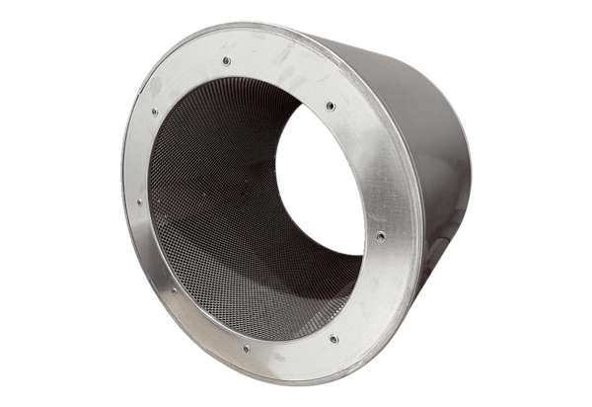Tubular sound absorber RSI 90/1500Packing unit: 1 pieceRange: C
Article number: 0073.0107Manufacturer: MAICO

