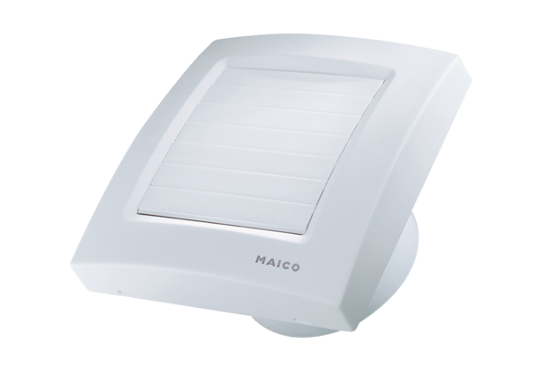Small room fan ECA 100 KIPacking unit: 1 pieceRange: A
Article number: 0084.0039Manufacturer: MAICO

