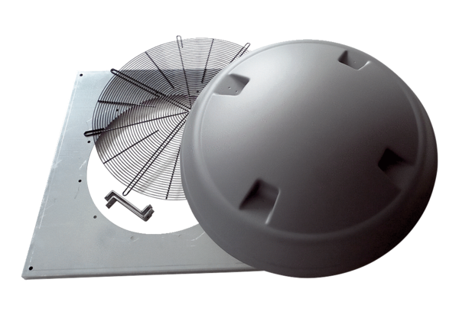Installation kit KIT DAD 90Packing unit: 1 pieceRange: C
Article number: 0073.0087Manufacturer: MAICO

