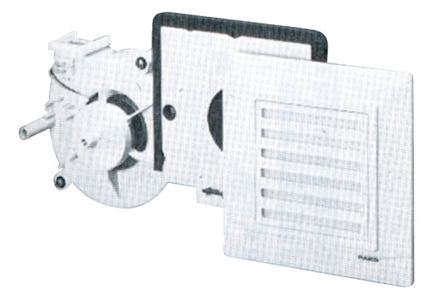Fan insert ER 17 FPacking unit: 1 pieceRange:
Article number: 0080.0237Manufacturer: MAICO

