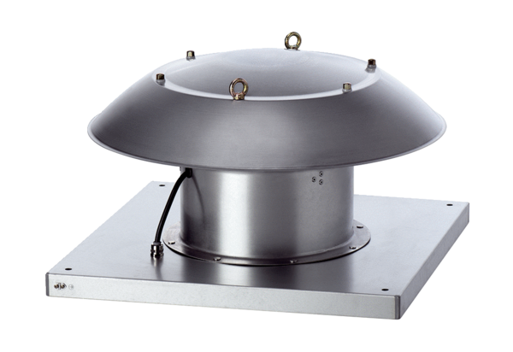Axial roof fan DZD 30/2 B Ex tPacking unit: 1 pieceRange: C
Article number: 0087.0814Manufacturer: MAICO

