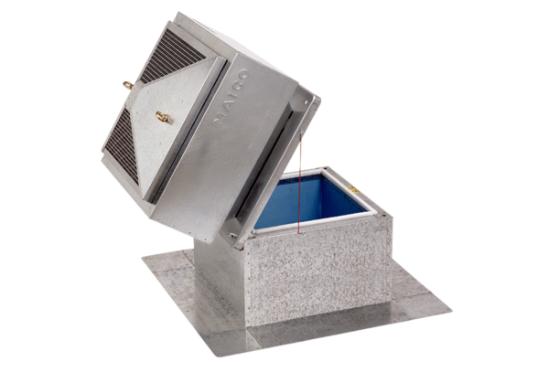Roof socket for flat roofs, tiltable SOK 25Packing unit: 1 pieceRange: C
Article number: 0093.0992Manufacturer: MAICO

