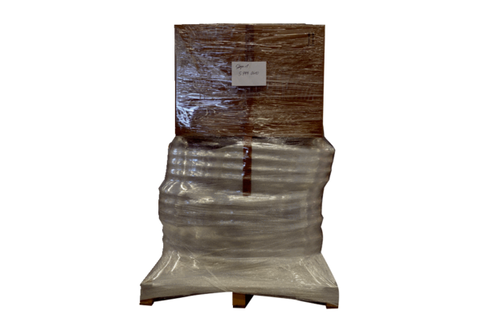Duct package LP 3 100/90Packing unit: 1 pieceRange: K
Article number: 5999.0030Manufacturer: MAICO

