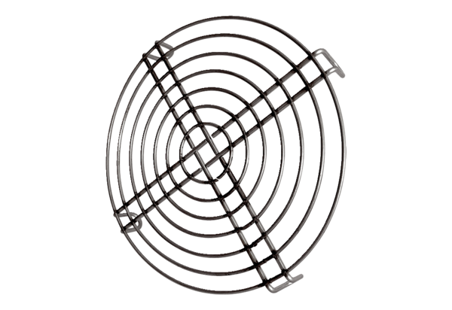Inlet protective grille SGEI K 31Packing unit: 1 pieceRange: C
Article number: 0073.0465Manufacturer: MAICO

