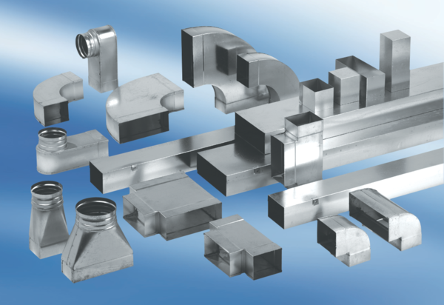90° channel elbows, long, vertical KB90LV/70/170Packing unit: 1 pieceRange: K
Article number: 0055.0578Manufacturer: MAICO

