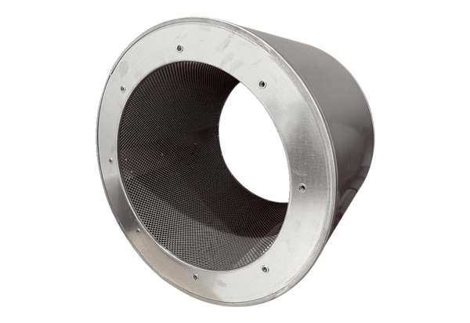Tubular sound absorber RSI 125/1500Packing unit: 1 pieceRange: C
Article number: 0073.0248Manufacturer: MAICO

