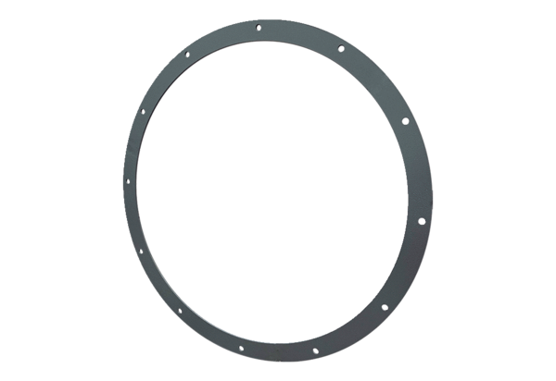Counter flange GFI 80Packing unit: 1 pieceRange: C
Article number: 0073.0261Manufacturer: MAICO

