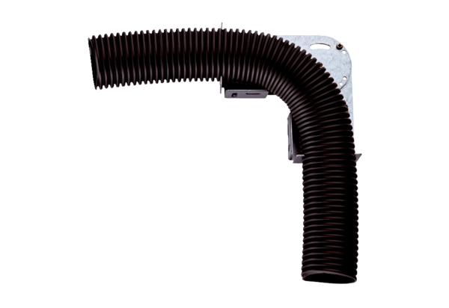Adjustable mounting bracket MF-FB63Packing unit: 1 pieceRange: K
Article number: 0018.0562Manufacturer: MAICO

