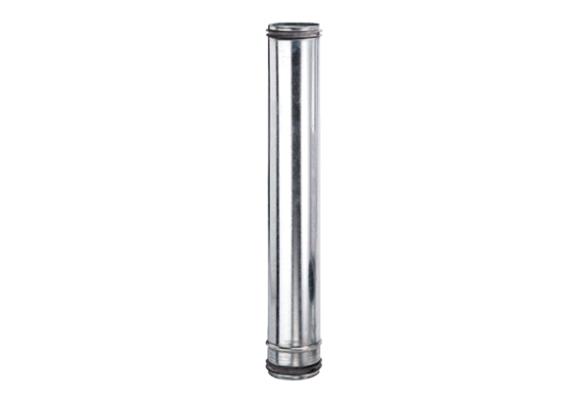Fire protection compensation element BA 200-0Packing unit: 1 pieceRange: B
Article number: 0093.1022Manufacturer: MAICO

