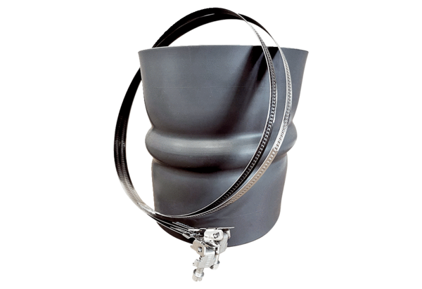Flexible cuff STKI 20Packing unit: 1 pieceRange: C
Article number: 0073.0488Manufacturer: MAICO

