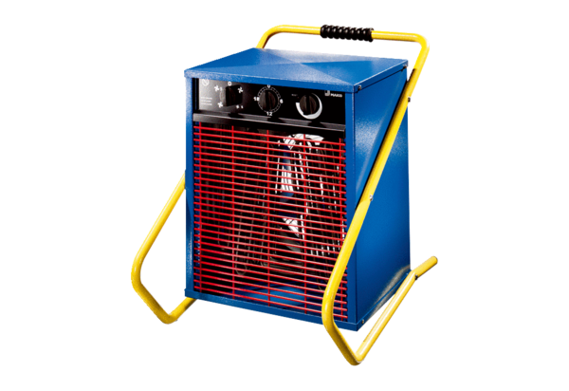Heater fan MHD 15Packing unit: 1 pieceRange: C
Article number: 0082.0203Manufacturer: MAICO

