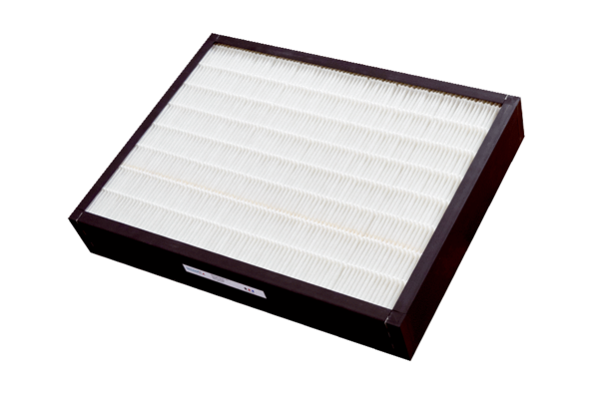Air filter, replacement CB 1200 F7Packing unit: 1 pieceRange: L
Article number: 0092.0580Manufacturer: MAICO

