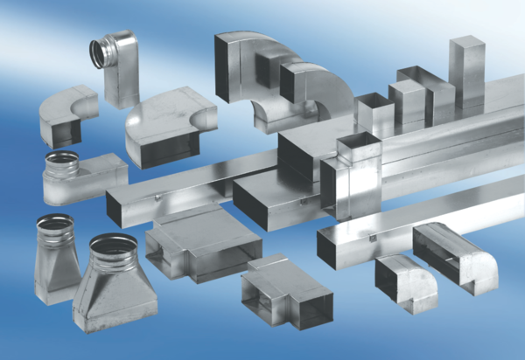90° channel elbows, short, horizontal KB90KH/80/100Packing unit: 1 pieceRange: K
Article number: 0055.0591Manufacturer: MAICO

