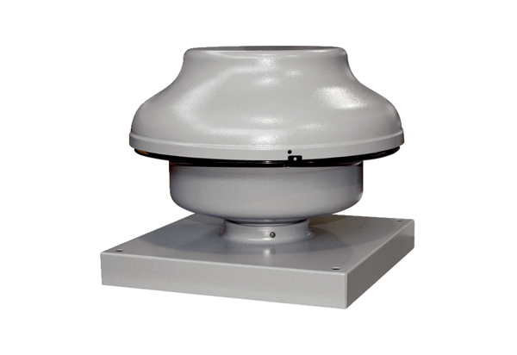Centrifugal roof fan EHD 10 ECPacking unit: 1 pieceRange: E
Article number: 0073.0559Manufacturer: MAICO

