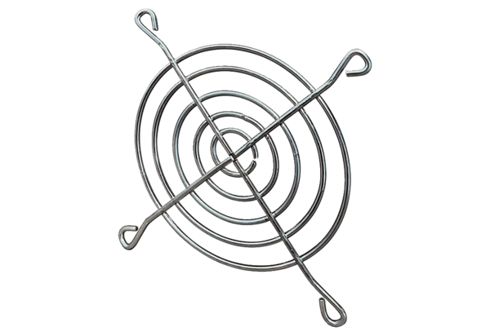Air outlet grille SGAI 10Packing unit: 1 pieceRange: C
Article number: 0073.0288Manufacturer: MAICO

