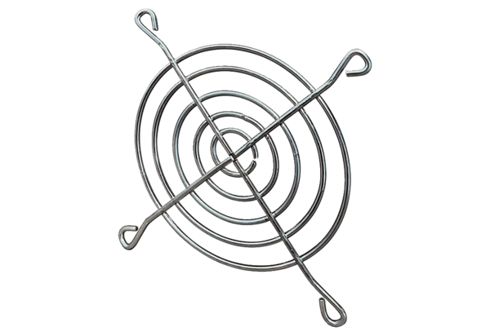Air outlet grille SGAI 18Packing unit: 1 pieceRange: C
Article number: 0073.0292Manufacturer: MAICO

