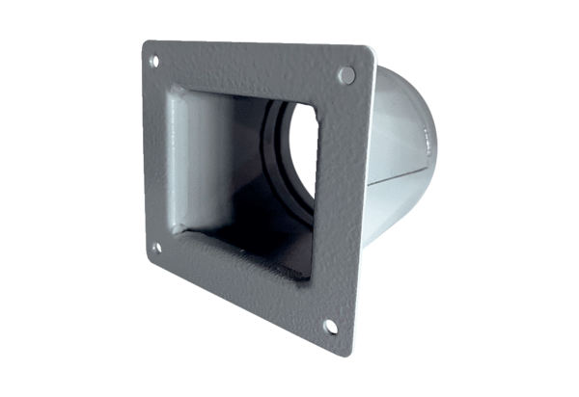Transition adapter URRI 10Packing unit: 1 pieceRange: C
Article number: 0073.0297Manufacturer: MAICO

